The program of reverse business mission from Turkey in the Chechen Republic
"26" - "27" February 2019

 | February 26 / wed.
1.50 | Flight from Istanbul to Grozny. Flight at 25.02 at 23.25 to 26.02 Arrivals at 1.50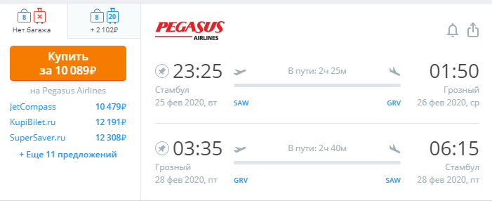
2: 00-2: 30 | Transfer to the hotel "Grozny City" http://groznycityhotel.ru/
9: 00-9.30 | Breakfast
10.00-18.00 | Visiting enterprises for the company profile
 | February 27 / Thurs
9:00-9.30 | Breakfast
10.00-13.00 | Visiting enterprises for the company profile
13.00-16.00 | Meeting with exporters in the "Exporter of the Year" - a solemn meeting and banquet
17.00-23.00 | Free time
 | February 28 Fri
1.00 | Airport transfer. Flight from Grozny to Istanbul Flight to 3.35 arrival at 6.15

